Go to MyMac Portal: https://my.mineralarea.edu/ics/
Click on MAC Alerts 2.0
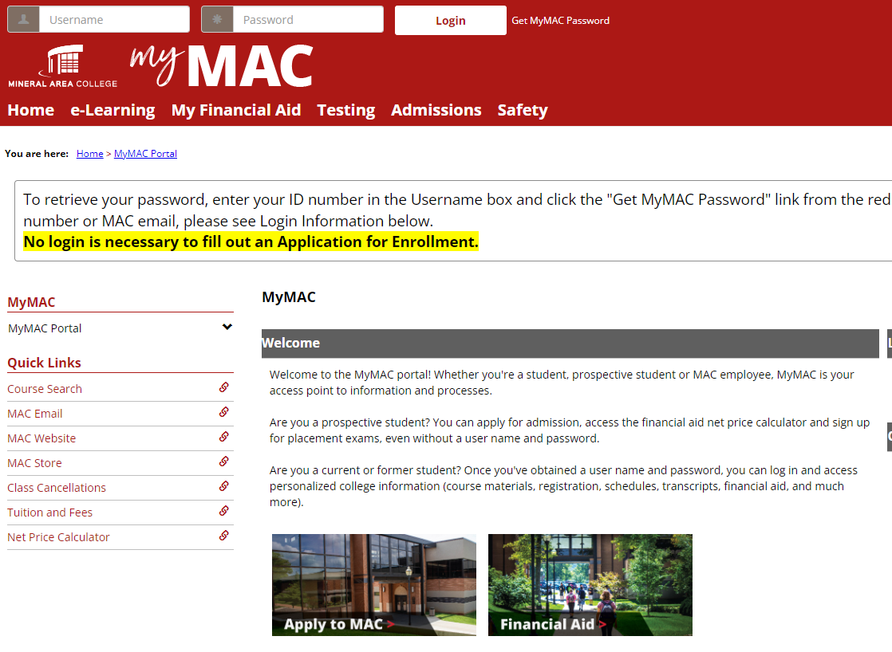

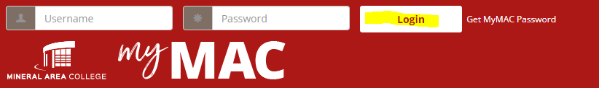
Log in using your network login (Example: ab123.stu) along with your MyMAC password.

Scroll down the left side of the page and click on the highlighted link.
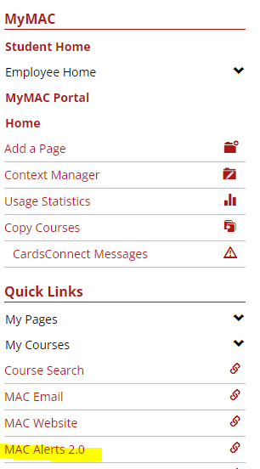

You will be taken to the login screen.
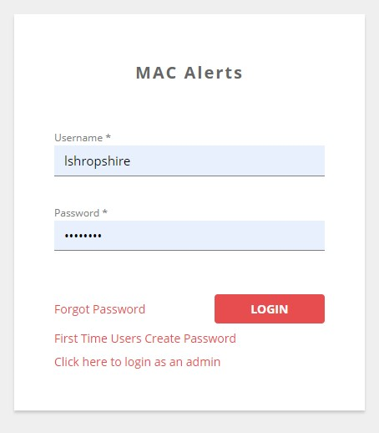

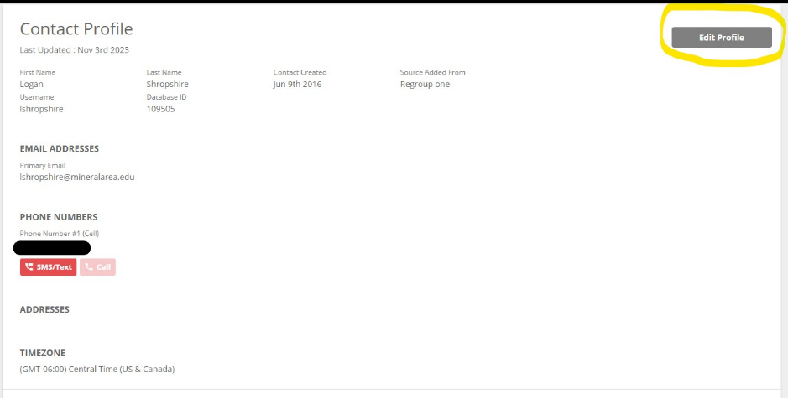
Once logged in, you should be taken to your profile. Then to edit your information, click the circled button labeled Edit Profile.

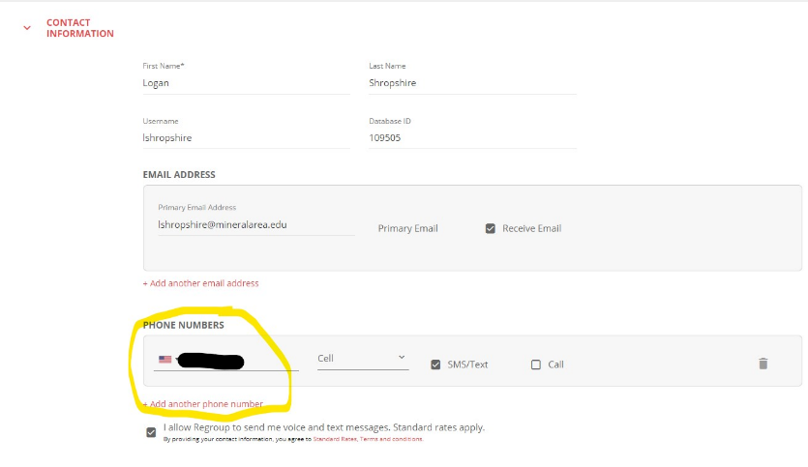
Once in the editable mode you are able to change or add phone number(s). See below.

Scroll down and save any changes you make and you are finished.

