Accessing Username and Passwords
Go to the MyMAC home page. Here you will be able either retrieve login information or to find out how to retrieve/set that information. Samples of results are below
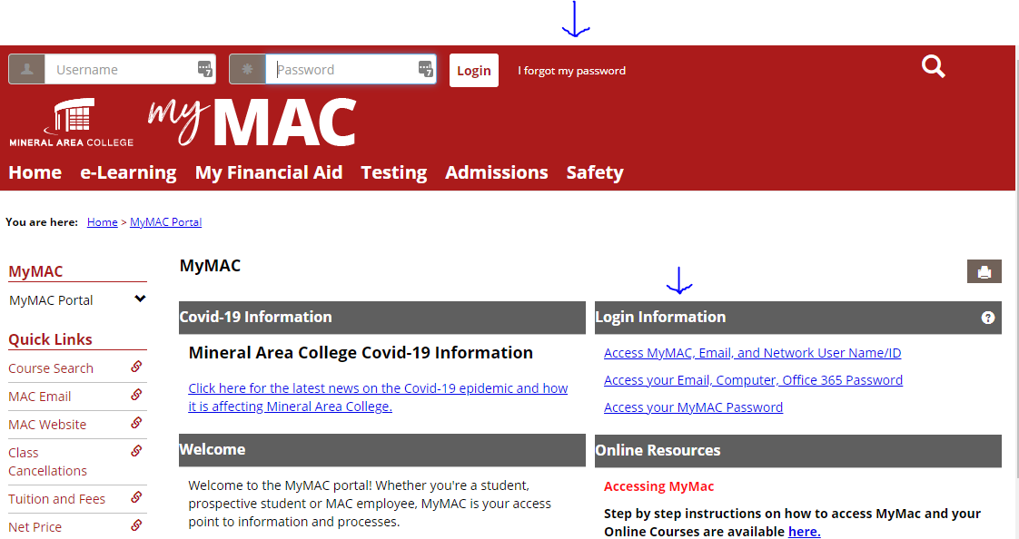

“Access MyMAC, Email, and Network User Name/ID”
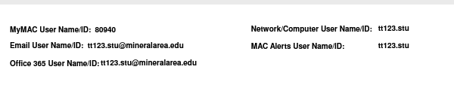
“Access your Email, Computer, Office 365 Password”
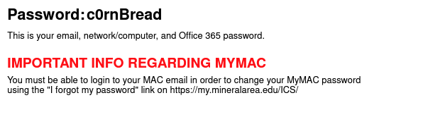
“Access your MyMAC Password” (This requires an active MAC Email)
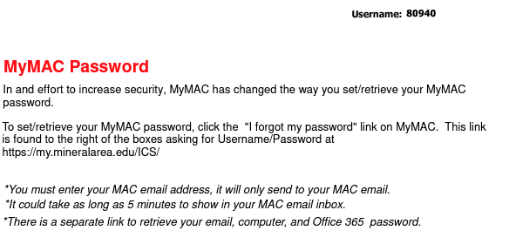
Changing Password
MyMAC
Click the profile picture in the top right and choose My profile & Settings
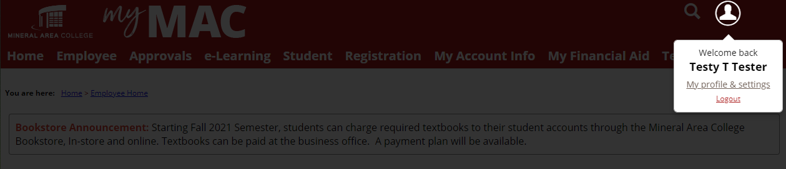
Once in “My profile”, click Password & Privacy from the left, then click the toggle button on the right next Change Password. Enter the information and click Save at the bottom of the screen.
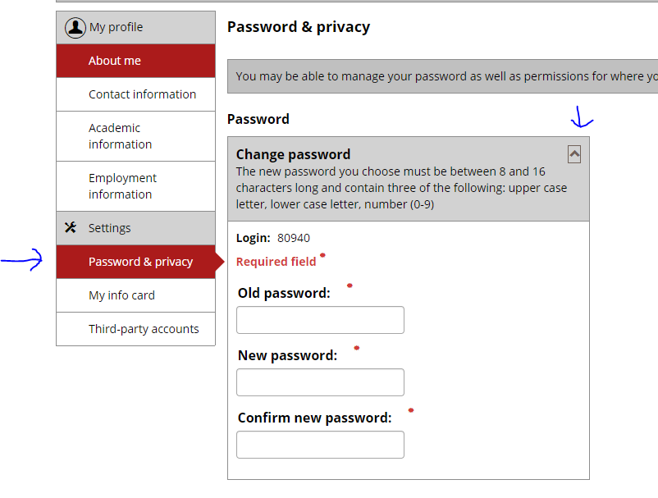
Additionally, you can click the “I forgot my password” and it will send a link to the MAC email address on file. (This could take 5 minutes to send)

Email, Computer, Office 365 Password
Once logged into MyMAC on the Student Home Page, click the Password Change for Email, Network/Computer Login, and Office 365. Enter the requested information. This process could take up to 10 minutes to sync.
